MINI PROJECT REPORT

## A MINI PROJECT REPORT ON

**“SYSTEM SURVEILLANCE USING KEYLOGGER”**

**Project ID: (CSE-AI-06/2022-23)**

**For the Degree of**

**Bachelor of Technology in Department of Computer Science & Engineering – Artificial Intelligence**

## SUBMITTED BY:

|  |  |
| --- | --- |
| **Rohit Gaware** | **2064191913031** |
| **Rohan Hardade** | **2064191913030** |
|  |  |
|  |  |

**UNDER THE GUIDANCE OF**

## Prof. Dipika Paranjape Mam



Department Of Computer Science & Engineering – Artificial Intelligence

## PCET- NMVPM’s,

**Nutan College of Engineering and Research, Talegaon, Pune**

***“Vision of the Institute”***

***“***To be a leading technological institute ensuring quality education giving rise to innovative technocrats, professionals and global citizens.***”***

## 2022-2023

**SEAL**

Nutan Maharashtra Vidya Prasarak Mandal’s

### NUTAN COLLEGE OF ENGINEERING AND RESEARCH

Under Administrative Support of Pimpri Chinchwad Education Trust

# CERTIFICATE

This is to certify that the Mini Project Report entitled **“System Surveillance Using Keylogger”**, which is being submitted by, **Rohit Gaware** and **Rohan Hardade** as partial fulfillment for the Third Year Degree of Bachelor of Technology (**Computer Science & Engineering – Artificial Intelligence**) of **DBATU, Lonere**

This is bonafide work carried under my supervision and guidance.

Place: Pune Date:

|  |  |
| --- | --- |
| **Project Guide** | **Dr. Ashwini Shinde**  **Project I/C** |
| **Prof. Priyanka Vyas Head of Department** | **Dr. Aparna Pande Principal** |

### External Examiner

# ACKNOWLEDGEMENT

The satisfaction & euphoria that accompany the successful completion of any task would be incomplete without the mention of people who made it possible . So I acknowledge all those whose guidance and encouragement served as a beacon light & crowned my efforts with success.

I have immense pleasure in expressing thanks to the principal **Dr. Aparna Pande** for providing all the facilities for the successful completion of the project.

With due respect, I thank my H.O.D. **Prof. Priyanka Vyas** Department of Computer Science & Engineering – Artificial Intelligence, for her motivating support, keen interest which kept my spirits alive all through.

I would like to express thanks to my guide **Prof. Dipika Paranjape,** Department of Computer Science & Engineering – Artificial Intelligence who has guided me throughout the completion of this project.

Finally I would like to thank all the teaching and non-teaching staff and all my friends who have rendered their support in the completion of this report.

**Name and Signature of student:**

|  |  |  |
| --- | --- | --- |
| **Sr.no** | **Name** | **Sign** |
| 1 | **Rohit Gaware** |  |
| 2 | **Rohan Hardade** |  |

**ABSTRACT**

In many companies, data security and recovery is now the most important factor. In many cases where data recovery is required. For these kinds of problems, a keylogger is one of the best solutions, which is often referred to as keylogging or keyboard capture. Keycapping is the act of recording keystrokes on a keyboard, usually covertly so that the person using the keyboard does not know that their actions are being monitored. With the help of keylogger application, users can get the data when the working file is corrupted due to several reasons like power loss etc. This is a tracking application used to track the users which records the keystrokes; uses log files to retrieve information. Using this application, we can recall a forgotten email or URL. In this keylogger project, whenever the user types something on the keyboard, the keystrokes are captured and sent to the admin email address without the user's knowledge within a set time.

## INDEX

|  |  |  |
| --- | --- | --- |
| **Sr.**  **No.** | **Content** | **Page No.** |
| 1 | **Introduction** | 7 |
| 1.1 | Problem Statement | 8 |
| 1.2 | Objectives | 8 |
| 1.3 | Scope | 8 |
| 2 | **Literature Review** | 9 |
| 3 | **System Analysis** | 10 |
| 3.1 | Existing System | 10 |
| 3.2 | Proposed System | 10 |
| 4 | **System Requirements** | 11 |
| 4.1 | Hardware Configuration | 11 |
| 4.2 | Software Configuration | 11 |
|  |  |  |
| 5 | **Working** | 12 |
| 6 | **Methodology** | 13 |
| 6.1  6.2 | Code Implementation  Output | 13  14 |
| 7  8 | **Conclusion**  **References** | 15  16 |

**INTRODUCTION**

In Malware is the process of disturbing system like collect sensitive data and gain access to systems [1]. Ancient authentication systems wont to defend access to on-line services (such as passwords) square measure prone to attack by the introduction of a keystroke faller to the service user's pc [2]. Detecting and preventing malware attack is very important in cyber world as malwares can badly affect computer operation. Once an hacker got access to private user data, he/she can easily make money transfer from user account to untrusted account. The private data can have many consequences which can prove to be more hazards than particular individual’s financial loss. We can summarize malware as program intentionally developed for damaging computer specifically those have internet connection [3]. Keyloggers square measure a significant threat to users and therefore the user’s information, as they track the keystrokes to intercept passwords and different sensitive data typewritten in through the keyboard. this provides hackers the good thing about access the PIN codes and account numbers, passwords to on-line searching sites, email id’s, email logins and different hint etc. when the hackers get access to the user’s private and sensitive information, they can take advantage of the extracted data to perform online money transaction the user’s account. Keyloggers will typically be used as a spying tool to compromise business and state-owned company’s information. the most objective of keyloggers is to interfere within the chain of events that happen once a secret is ironed and once the information is displayed on the monitor as a results of a keystroke. Fig shows the Image of keylogger.

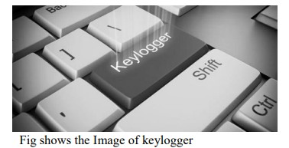

A keylogger can be done by introducing a wiring or a hardware bug in the keyboard, to achieve video surveillance, terminating input/output, or by also implementing the use if a filter driver in the keyboard stack. Extracting information from the user’s keyboard exploitation generalized documented ways. The log file created by the keylogger may be sent to the required receiver. Some keyloggers programs will record any email addresses that you just have used and URL’s of any websites that you just visit. There square measure 2 different rootkit ways employed by hackers: masking in kernel mode and masking in user mode. during this paper we tend to specialise in the literature survey that is said to keylogger, its types, interference detection of keylogger attacks and its varied applications.

### 1.1 PROBLEM STATEMENT

Hackers and other third parties are always looking for the vulnerabilities present inside the system. To gain knowledge about what they require from the organizations, they either gain access to the confidential data stored in the system and either cause harm to the integrity of data or may cause data loss. Another problem is that cyber crimes are increasing day by day. If we will have the chat logs or keystroke logs of victim’s laptop then we can easily analyze the entire planning of the victim which will provide the best solution to eradicate or solve the problem.

### OBJECTIVES

1. Develop a keystroke logging software to accurately and discreetly record all keystrokes made on a target system.
2. Capture keystrokes in real-time, including letters, numbers, special characters, and function keys.
3. Implement a secure storage mechanism to store the recorded keystrokes, ensuring data confidentiality and integrity.
4. Create a user-friendly interface to view and manage the recorded keystrokes effectively.
5. Explore the possibility of capturing keystrokes from multiple input sources, including physical keyboards, virtual keyboards, and on-screen keyboards

### SCOPE OF PROJECT

Keylogger is basically using keystroke logs to monitor the system and send the details to the admin through the mail server. Keyloggers provide the best solutions in case of such cases like; IT organizations can indicate their concerns by going after the culprit whose performance is deteriorating that of the whole organization, parents can maintain a check on their children’s activities, a particular person’s activities can be monitored, storing passwords of various social media profiles. Above all, keylogger is one of the best implementation of fundamentals of ethical hacking. By using this some measures could be done accordingly that would save personal data from being in the hands of total strangers.

### 2. LITERATURE REVIEW

In [1] we observe that To make recognizing keyloggers all the more conceivable, it is important

for individuals to get a handle from top to bottom information about what keyloggers really are, how they work implement and understand a different approach to it. On answers to this kind of questions we will discuss about different the kind of algorithm that has been proposed so far to overcome the problem and also the disadvantages of the proposed system. Key recording is a

stock trading practice that should be possible from multiple points of view. When the attacker

gain physical access to your computing devices that may eavesdrop on physical hardware such as the keyboard to collect them valuable user data. This strategy is completely dependent on some real properties, either sound transmission created when the client composes or electromagnetic remote console propagation (Santripti Bhujel | Mrs. N. Priya 2022).

In [2] we found out External keyloggers or hardware keyloggers are small an electronic device

that is placed between the keyboard and motherboards, this procedure requires attackers to have a physical access to the system to which they are intended compromise. Keyloggers are performed on targeted machine for recording client keystrokes finally, the transfer of this private information to a third party (Kavya .C, Suganya.R 2021).

In [3] we observed Keyloggers are used for both legal and illegal purposes. Attackers usually use keyloggers to obtain private information of an individual or an association. In the past a lot of credit card information has been misused attackers using keyloggers. Keyloggers from now on are one of the most dangerous types of spyware to date, ( Devashree Kataria , Manan Kalpesh Shah ,

S Bharath Raj , Priya G 2020).

In [4] we discover Malicious programs using the keystroke logging feature an example of a real-time online banking system. Off the chance that some of the frame capacities were erroneously updated, may represent attacker to gain access to theclient ledger. The the loophole of these attacks can be easily removed if the gadget keeps asking for a brand new set characters or alphabets regardless of whether the login is successful (Disha H. Parekh, Nehal Adhvaryu, Vishal Dahiya 2020).

In [5] we found out that As examination depends on individual positions and now not to the specific character styles that are allowed inside the verification code, allowing codes to contain a could not have a more distinctive assortment of characters remove the weakness, even though it would be possibly improve security in various ways. He too proposed an extension of the permissible lengths authentication codes could put the attack to sleep, but they could now do not change the straightforward situation. In total the central issue is the enemy of key logging frameworks done in that particular way will reasonably invalidate theirs entire consideration (Jia Wang, Brent Lagesse 2020).

3**. SYSTEM ANALYSIS**

Authorized use of a keylogger is use of such software with the knowledge and consent of the PC Owner or security administrator. As a rule, authorized monitoring software products require physical access to computer and administrative privilege for configuration and installation that excludes (or at least minimizes) risks of unauthorized use of programs. As per the rule, such software products have ability to obtain and configure a “packed” installation executable file that is delivered to the user’s computer with the help of various ethical and authorized schemes. During installation it doesn’t display any messages or create any windows on the screen

**3.1 Existing System**

The Features of designed Keylogger that are implemented and are going to be implemented

In this Project :

* + Keystroke Recording
  + Remote Monitoring
  + Email Reports

**3.2 Proposed System**

1. **Smtplib:** The module included in python defines an SMTP client session object that can be used to send mail to any internet machine with an SMTP listener daemon.
2. **Threading:** It is one of the modules provided with python includes a simple-to-implement locking mechanism that allows you to synchronize threads.
3. **keyboard:** This module allows you to take complete control of your keyboard, hook global events, register hotkeys, simulate key presses, and much more, and it is a small module, though

## 4. SYSTEM REQUIREMENTS

Authorized The product will be operating in windows operating system and Linux operating system environment. The hardware configuration include Hard Disk 40 GB, Monitor.15” Color Monitor and Keyboard 122 keys. The basic input devices required are keyboard, mouse and output devices are Monitor, Mobile Devices etc.

**4.1** **Hardware Requirements**

The Operating System - Windows and Linux specified

RAM - 512 MB

Hard Disk - 1 GB working space ( Minimum Requirement )

**4.2 Software Requirements**

Languages - Python

Tools - Visual Studio code Python 3.10

Technology - Advanced programming using Python

### 5. Working

The Keylogger basically has three functions START, STOP, HIDE. We have implemented hook procedure in the system. when the keylogger starts, hook procedure logs the keys that are typed by the user. Then its sends captured data to main module. The main module then sends text document to specific Email and saves offline copy on data.

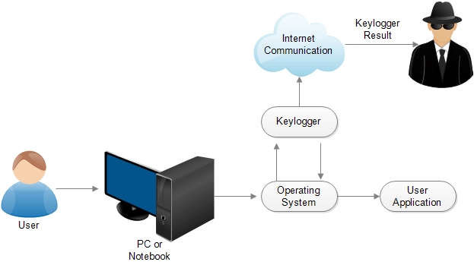

**System Flow Diagram**

**6. METHODOLOGY**

**6.1 Code Implementation**

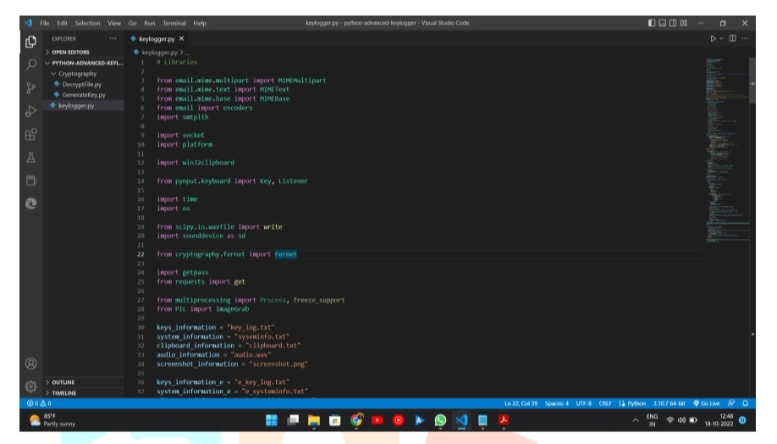

**Code For Keylogger**

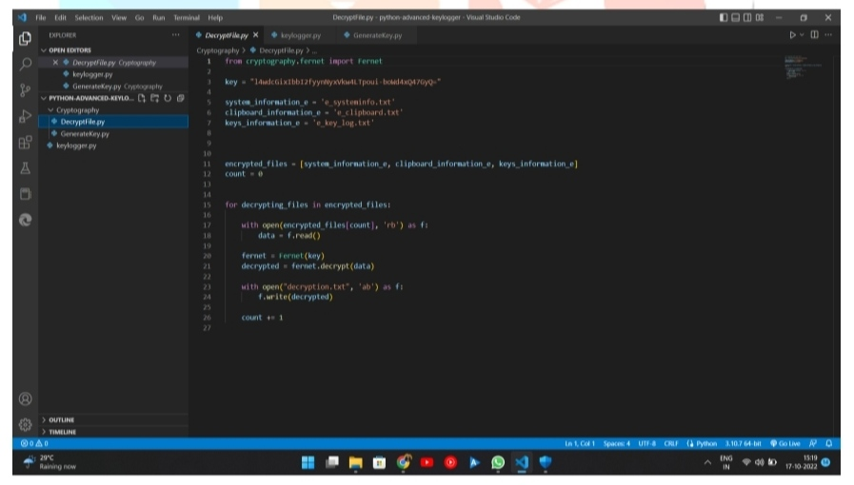

**Code For Decrypt File**

## 6.2 Output

## 

## Output Of Text File Send Through Email

## CONCLUSION

A Keylogger is a form of software which is used to track or log the all the keys that a user strikes on their keyboard, usually in secret so that the user of the system doesn’t know that their actions are being monitored. It is otherwise known as keyboard capturer. These are perfectly legal and useful. They can be installed by employers to oversee. A Keylogger is a form of software which is used to track or log the all the keys that a user strikes on their keyboard, usually in secret so that the user of the system doesn’t know that their actions are being monitored. It is otherwise known as keyboard capturer. These are perfectly legal and useful. They can be installed by employers to oversee the use of their computers, meaning that the employees have to complete their tasks instead of procrastinating on social media. Some of the possible amendments and improvements in this project are;

• Adding screenshots of pages visited

• Recording of system screen

• Full remote cloud monitoring

• Screenshot of immediately changed pages

• Secure web account for data storing

• Password Protection • Parental Control

## REFERENCES

1. Malware Definition Available at http://en.wikipedia.org/wiki/Malware.

2. S. P. Goring, J. R. Rabaiotti and A. J. Jones, “Anti-keylogging measures for secure internet login: an example of the law of unintended consequences”, Computers & Security, Page 1-9, Feb 2007.

3. AntiHook Shield against the Software Keyloggers. Aslam at el. (2004)

4. Analysis and Implementation of Decipherments of Keylogger, Parth Mananbhai Patel, Prof. Vivek K.ShahParth (2015).

5. Bait Your Hook: A Novel Detection Technique for Keyloggers,Stefano Ortolani, Cristiano Giuffrida, Bruno Crispo (2010).

6. Survey of Keylogger Technologies, Yahye Abukar Ahmed, Mohd Aizaini Maarof, Fuad Mire Hassan and Mohamed Muse Abshir, International Journal of Computer Science and Telecommunications, Volume 5, Issue 2, February 2014.

7. Cyber Security – KEYLOGGERS Comparison of Detection Techniques & Its Legitimate Use A Aaradhya Gorecha Information Technology Department SVKM NMIMS MPSTME, Shirpur, Maharashtra, India.

8.Malware Definition Available at <https://www.wisegeek.com/what-is-malware>.

9.<https://www.csoonline.com/article/3326304/what-is-a-keylogger-how-attackers-can-monitoreverything-you-type.html/>

10. <https://www.ntiva.com/cyber-security-services/>

11. geeksforgeeks.org/cryptography-introduction/

12. <https://sec.okta.com/articles/2020/12/password-spraying-attacks-and-how-prevent-them>

13. <https://info-savvy.com/password-attacks/>

14. <https://searchsecurity.techtarget.com/definition/keylogger>

15. <https://www.veracode.com/security/keylogger>